成绩
批阅
日期

台州学院
电子与信息工程学院实验报告
Experimental Report of the School of Electronic and Information Engineering

班级(class) 24计算机（留（（英） 学号(code) 2462710034L
姓名(full name) JENIRA SEKAR AZ ZAHRA （仙女）

实验课程： web前端开发 (web front-end development)
实验名称:实验一 HTML编程实践 (lab1 HTML Programming Practice)

实验日期(Date)： 2025 年(year) 10 月(month) 4 日(day)

一、实验目的和任务（Experimental requirements & tasks）
1. 了解HTML 文档结构，学习如何编写HTML文档；
（understand the structure of HTML documents and learn how to write HTML documents）
- 学习基本的 HTML 标签，理解各种标签的使用场景;
( Learn basic HTML tags and understand the usage scenarios of various tags)
- 能够运用常用的编辑器建立简单的HTML文档。
(eable to create simple HTML documents using common editors.)
- 实验环境(Experimental environments)
r Windows+Hbuilderx
r Windows+VSCode
r Mac+Hbuilderx
r Max+VSCode
r Others
- 实验内容与步骤(Experimental procedure)
- HTML structure:
<!DOCTYPE html>
<html lang="en">
<head>
<meta charset="UTF-8" />
<meta name="viewport" content="width=device-width, initial-scale=1.0" />
<title>Research Institution Showcase</title>
<link rel="stylesheet" href="style.css" />
</head>
<body>
<div class="header">
<a href="#">Home</a>
<a href="#">About</a>
<a href="#">Contact</a>
</div>
<div class="container">
<div class="box c1 top-left">
<h2>Key Fields</h2>
<img src="img/sample.jpg" alt="Key Fields" />
<span>Attaching Great Importance to Application</span>
</div>
<div class="box c2 top-right">
<h2>Key Platforms</h2>
<img src="img/glass.jpg" alt="Key Platforms" />
<span>Leading the Era & Advancing with the Times</span>
</div>
<div class="box c3 bottom-left">
<h2>Teams</h2>
<img src="img/prof.jpg" alt="Teams" />
<span>One swallow does not make a summer</span>
</div>
<div class="box c4 bottom-right">
<h2>Achievements</h2>
<img src="img/scientist.jpg" alt="Achievements" />
<span>Microbunching Illuminates New Technology</span>
</div>
</div>
</body>
</html>
- CSS styling:
body {
margin: 0;
padding: 0;
font-family: "Arial", sans-serif;
background-color: #f0f0f0;
}

.header {
position: fixed;
height: 60px;
color: white;
background-color: black;
width: 100%;
top: 0;
z-index: 10;
}

.header a {
color: white;
text-decoration: none;
display: inline-block;
padding-left: 50px;
padding-top: 25px;
}

.container {
position: relative;
width: 800px;
height: 600px;
margin: 80px auto 0;
border: 1px solid #ddd;
}

.box {
width: 400px;
height: 300px;
text-align: center;
line-height: 50px;
position: absolute;
overflow: hidden;
}

.c1 {
background-color: aquamarine;
top: 0;
left: 0;
z-index: 1;
}

.c2 {
background-color: bisque;
position: relative;
top: 0;
left: 400px;
}

.c3 {
width: 400px;
position: relative;
top: 0;
left: 0;
background-color: #ffd700;
}

.c3 img {
width: 100%;
height: 250px;
}

img {
width: 100%;
height: 250px;
display: block;
}

.c1 span,
.c2 span,
.c3 span,
.c4 span {
position: absolute;
bottom: 0px;
display: block;
color: red;
font-size: 1.2em;
background-color: rgba(115, 178, 233, 0.8);
height: 50px;
width: 100%;
line-height: 50px;
z-index: 2;
}

.c4 {
background-color: chartreuse;
position: relative;
left: 400px;
bottom: 300px;
}

h2 {
position: absolute;
top: 10px;
left: 10px;
margin: 0;
color: white;
text-shadow: 1px 1px 2px rgba(0, 0, 0, 0.5);
z-index: 3;
background: rgba(0, 0, 0, 0.5);
padding: 5px 10px;
border-radius: 3px;
}
- Header section:
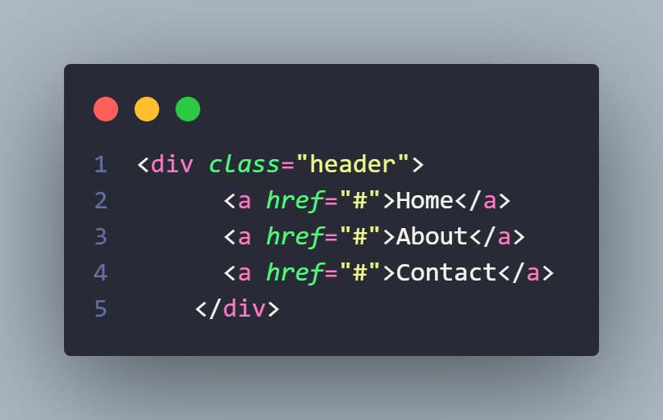

- Main section:
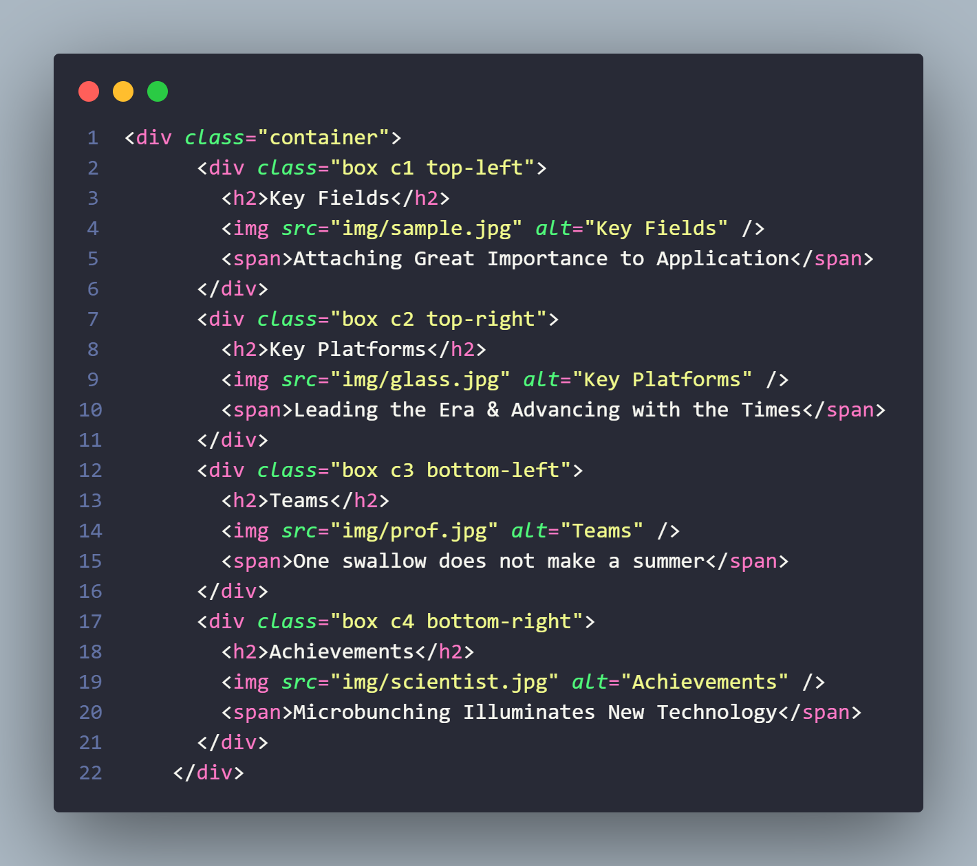
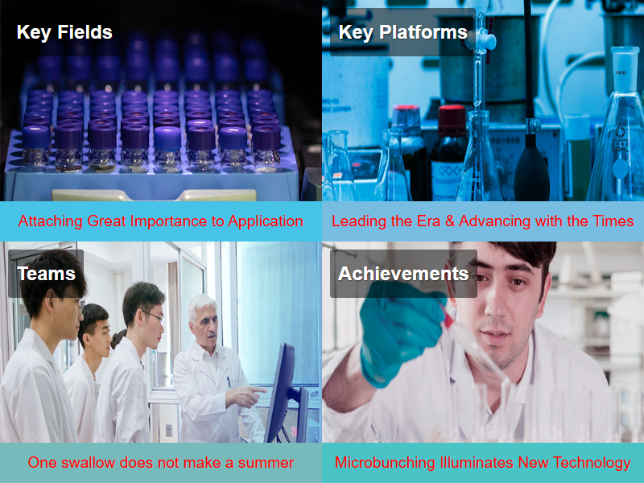
- 实验结果分析、思考、心得（Result reflection）

Through this experiment, I have deepened my understanding about positioning in CSS. I have learned how to align content using relative and absolute position with top, bottom, left, and right properties. Fixed position for sticking a content into a place we want it to be. It makes better alignment in the making of a website.

